**SECURIN ASSESSMENT – SRM**

**Debanjan Basak (RA2011003010606)**

**Part-A (15-20 Minutes):**

**1. How many total combinations are possible? Show the math along with the code!**

The total number of combinations possible when rolling multiple dice can be calculated using the exponentiation of the number of faces by the number of dice rolled.

Mathematical Explanation:

For n dice rolled, each having 6 faces, the total combinations are calculated using the formula: 6^*n*, where:

* n is the number of dice rolled.
* 6 represents the number of faces on each die.

Example Calculations:

* For 1 die: 61=661=6 combinations.
* For 2 dice: 62=3662=36 combinations.
* For 3 dice: 63=21663=216 combinations.

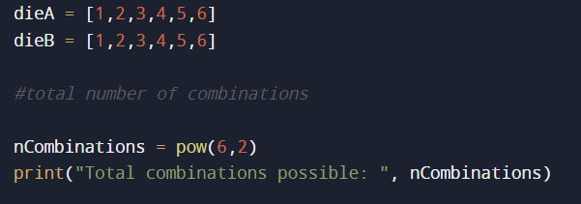



**2. Calculate and display the distribution of all possible combinations that can be obtained when rolling both Die A and Die B together. Show the math along with the code!**

**Hint: A 6 x 6 Matrix.**

The logic involves considering each possible outcome of Die A (1 to 6) and pairing it with each possible outcome of Die B (also 1 to 6), resulting in 36 unique combinations (6 outcomes of Die A multiplied by 6 outcomes of Die B).

The code uses nested loops to calculate the sum of outcomes for each combination and fills a 6 x 6 matrix accordingly. Finally, the matrix displays the sum of outcomes when both dice are rolled together, showcasing all potential combinations of the two dice.

Example Calculation:

For each outcome on Die A (from 1 to 6), there are 6 possible outcomes on Die B, resulting in a total of 36 unique combinations:

* Die A outcome 1 combined with Die B outcomes 1 to 6 (1+1, 1+2, 1+3, 1+4, 1+5, 1+6)
* Die A outcome 2 combined with Die B outcomes 1 to 6 (2+1, 2+2, 2+3, 2+4, 2+5, 2+6)
* ... and so on until Die A outcome 6 combined with Die B outcomes 1 to 6 (6+1, 6+2, 6+3, 6+4, 6+5, 6+6)

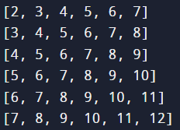

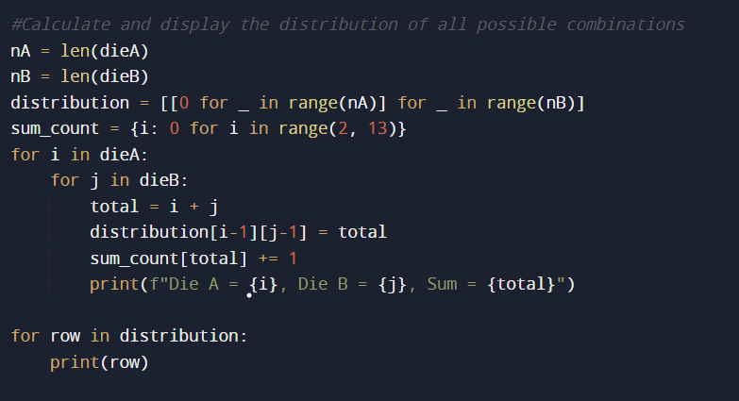

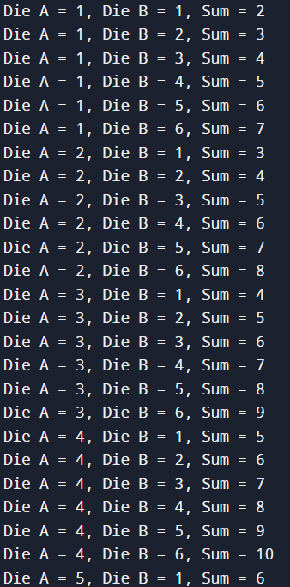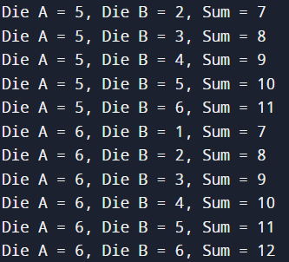

**3. Calculate the Probability of all Possible Sums occurring among the number of combinations from (2).**

**Example: P(Sum = 2) = 1/X as there is only one combination possible to obtain**

**Sum = 2. Die A = Die B = 1**

To find the probability of all possible sums occurring among the combinations of both dice, we can create a table or chart to represent the outcomes and their probabilities.

Considering two dice, A and B, with the following elements:

Die A: 1, 2, 3, 4, 5, 6

Die B: 1, 2, 3, 4, 5, 6

We'll first list all the possible sums that can occur when rolling both dice and then calculate the probability of each sum.

Possible sums and their respective probabilities:

| **Sum** | **Ways to obtain the sum** | **Probability** |
| --- | --- | --- |
| 2 | 1+1 | 1/36 |
| 3 | 1+2, 2+1 | 2/36 |
| 4 | 1+3, 2+2, 3+1 | 3/36 |
| 5 | 1+4, 2+3, 3+2, 4+1 | 4/36 |
| 6 | 1+5, 2+4, 3+3, 4+2, 5+1 | 5/36 |
| 7 | 1+6, 2+5, 3+4, 4+3, 5+2, 6+1 | 6/36 |
| 8 | 2+6, 3+5, 4+4, 5+3, 6+2 | 5/36 |
| 9 | 3+6, 4+5, 5+4, 6+3 | 4/36 |
| 10 | 4+6, 5+5, 6+4 | 3/36 |
| 11 | 5+6, 6+5 | 2/36 |
| 12 | 6+6 | 1/36 |

The probabilities are calculated by considering the number of ways to obtain each sum and dividing it by the total number of possible outcomes, which is 36 (since each die has 6 sides).

Therefore, this table represents the probabilities of all possible sums when rolling both dice, considering the combinations of their outcomes.

**Logic: -**

1. **Identify Possible Sums**: When two dice are rolled simultaneously, the minimum sum possible is 2 (when both dice show 1), and the maximum sum is 12 (when both dice show 6).
2. **Count Occurrences of Sums**: Iterate through all possible combinations of rolls for both dice (each die has 6 faces) and calculate the sum for each combination. Keep track of how many times each sum occurs.
3. **Calculate Probabilities**: Divide the count of occurrences for each sum by the total number of possible combinations to find the probability of obtaining that particular sum.

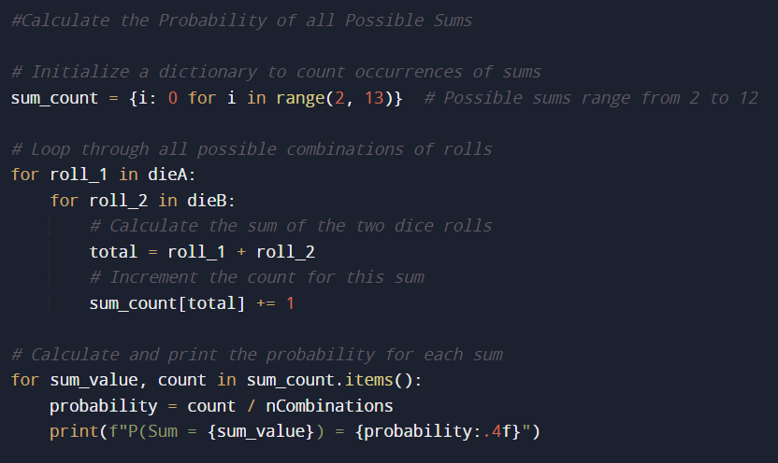

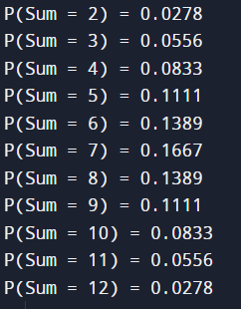

**Part-B (25-30 Minutes):**

Now comes the real challenge. You were happily spending a lazy afternoon playing your board game with your dice when suddenly the mischievous Norse God Loki ( You love Thor too much & Loki didn’t like that much ) appeared.

Loki dooms your dice for his fun removing all the “Spots” off the dice.

No problem! You have the tools to re-attach the “Spots” back on the Dice.

However, Loki has doomed your dice with the following conditions:

● Die A cannot have more than 4 Spots on a face.

● Die A may have multiple faces with the same number of spots.

● Die B can have as many spots on a face as necessary i.e. even more than 6.

But in order to play your game, the probability of obtaining the Sums must remain the same!

So if you could only roll P(Sum = 2) = 1/X, the new dice must have the spots reattached such that those probabilities are not changed.

Input:

● Die_A = [1, 2, 3, 4, 5, 6] & Die B = Die_A = [1, 2, 3, 4, 5, 6]

Output:

● A Transform Function undoom_dice that takes (Die_A, Die_B) as input &

outputs New_Die_A = [?, ?, ?, ?, ?, ?],New_Die_B = [?, ?,

?, ?, ?, ?] where,

● No New_Die A[x] > 4

So,

**Logic: -**

1. **Initial Conditions:**
   * Two dice: Die A and Die B.
   * Die A must have faces with no more than 4 spots, while Die B can have any number of spots on a face.
2. **Loki's Challenge:**
   * Loki removed all spots from the dice, requiring them to be reattached.
   * The task is to reattach spots to Die A and Die B while preserving the original probabilities of obtaining specific sums when rolling both dice.

**Solution Approach:**

1. **Probability Computation:**
   * Understand and compute the probabilities for each possible sum when rolling two dice.
2. **Dice Transformation:**
   * Create a function to transform Die A adhering to Loki's constraints: faces cannot exceed 4 spots.
   * Iterate through Die A, replacing faces greater than 4 with 4.
   * Recalculate probabilities for the modified Die A and check against the original probabilities.
3. **Validation and Output:**
   * If the recalculated probabilities match the target probabilities within a threshold, consider the transformation successful.
   * Output the new configurations for Die A and Die B if the transformation meets all conditions.

This solution combines understanding probabilities, adjusting dice faces, and validating the transformed probabilities to satisfy Loki's challenge while maintaining the desired sum probabilities.

